Test Case: tc002_SPX_Dev5_Crear_Requisicion_Spot_Tipo_Cobro_Project
Step 1 - Enter username and password and click to button Enter: Credentials Entered
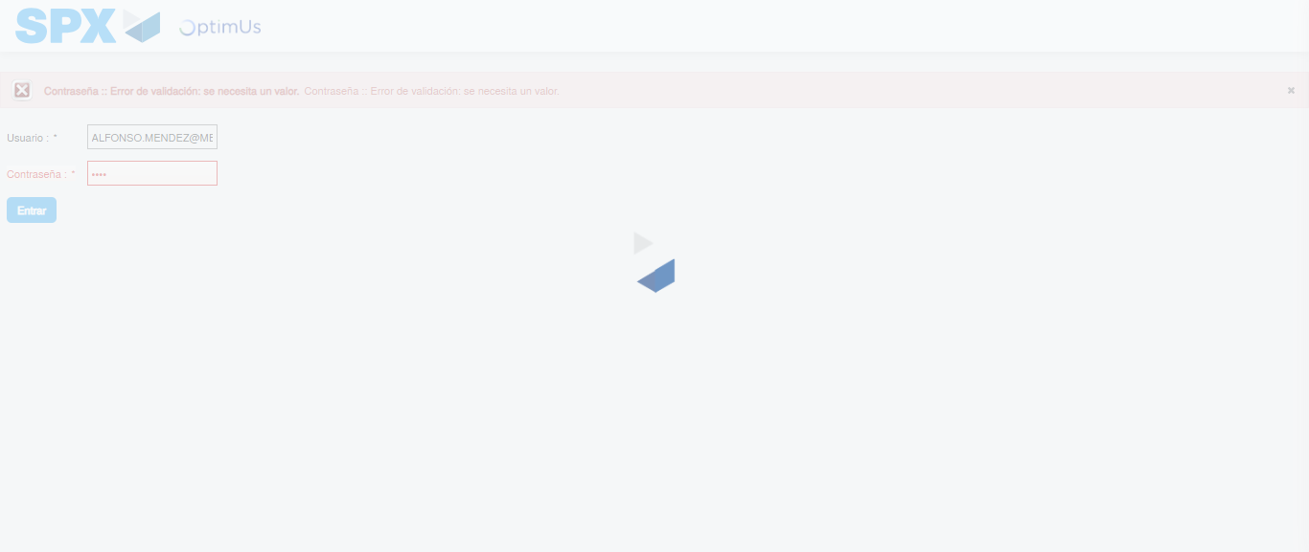Image file-name: QC_Testing-tc002_SPX_Dev5_Crear_Requisicion_Spot_Tipo_Cobro_Project-1784308291345

Step 2 - Select to UEN and Access to Spot Buy Requisitions : UEN Correctly selected and Correct access
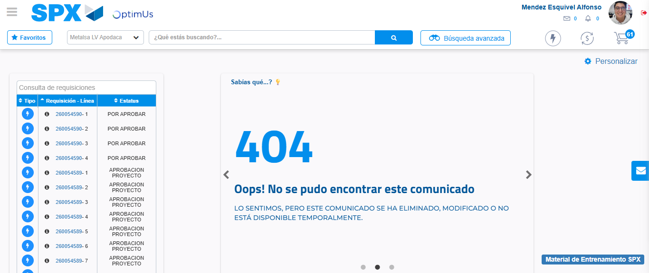Image file-name: QC_Testing-tc002_SPX_Dev5_Crear_Requisicion_Spot_Tipo_Cobro_Project-1784308356957

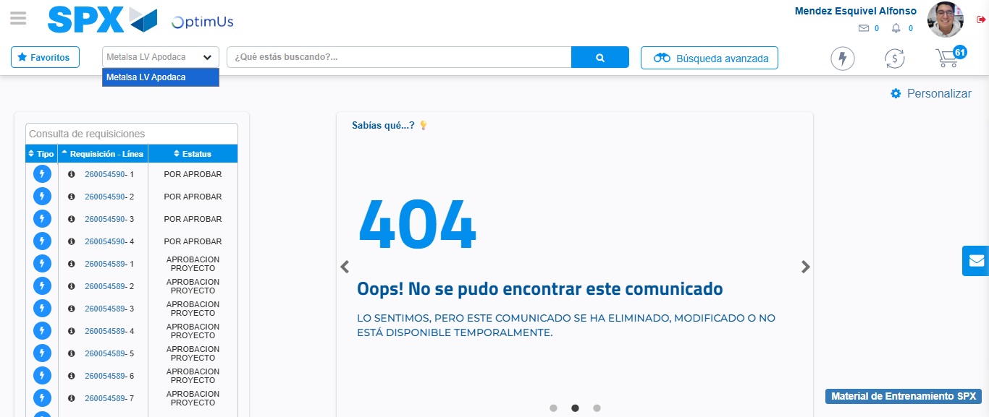Image file-name: QC_Testing-tc002_SPX_Dev5_Crear_Requisicion_Spot_Tipo_Cobro_Project-1784308359399

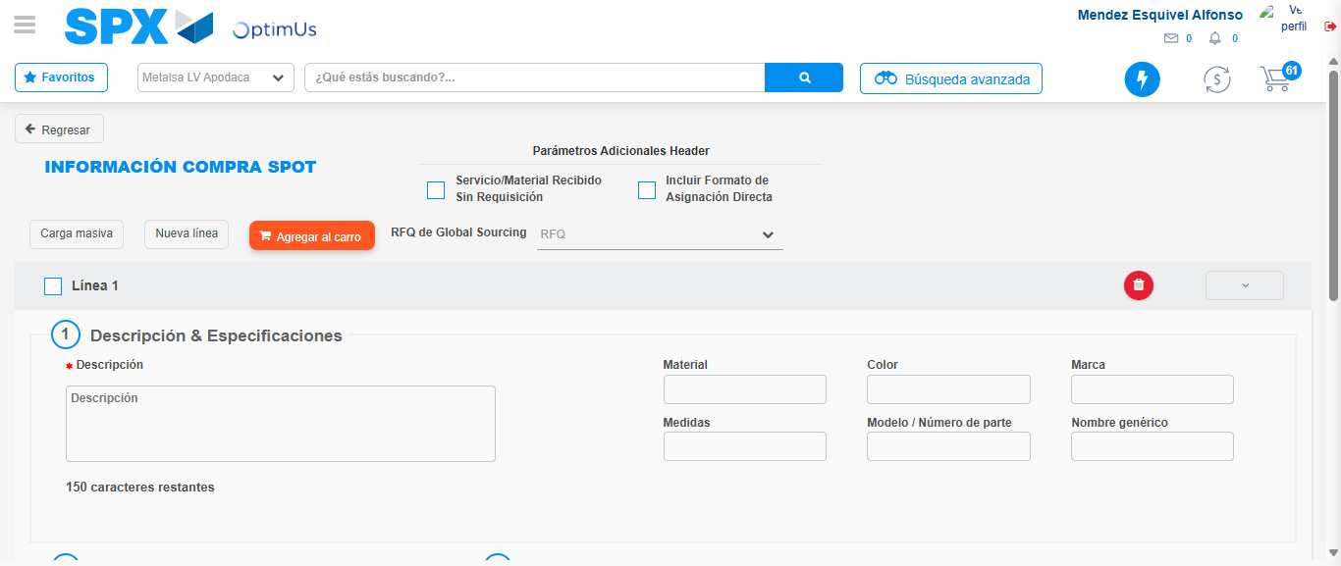Image file-name: QC_Testing-tc002_SPX_Dev5_Crear_Requisicion_Spot_Tipo_Cobro_Project-1784308368462

Step 3 - Data Capture Spot Buy Requisition: Data captured correctly
Image file-name: QC_Testing-tc002_SPX_Dev5_Crear_Requisicion_Spot_Tipo_Cobro_Project-1784308368687

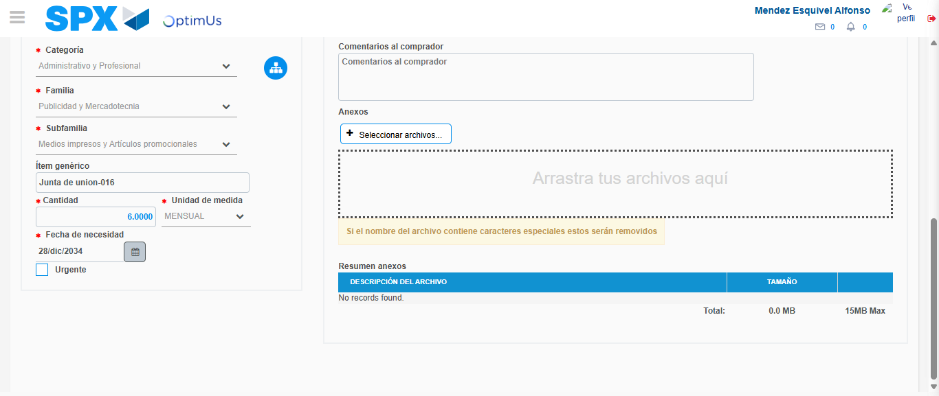Image file-name: QC_Testing-tc002_SPX_Dev5_Crear_Requisicion_Spot_Tipo_Cobro_Project-1784308379118

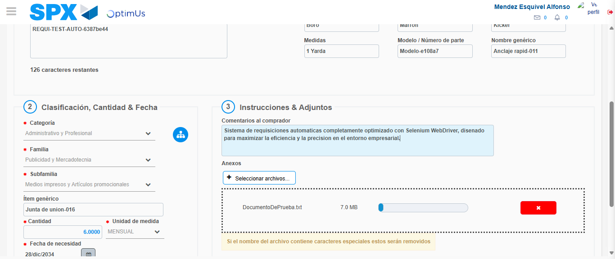Image file-name: QC_Testing-tc002_SPX_Dev5_Crear_Requisicion_Spot_Tipo_Cobro_Project-1784308379833

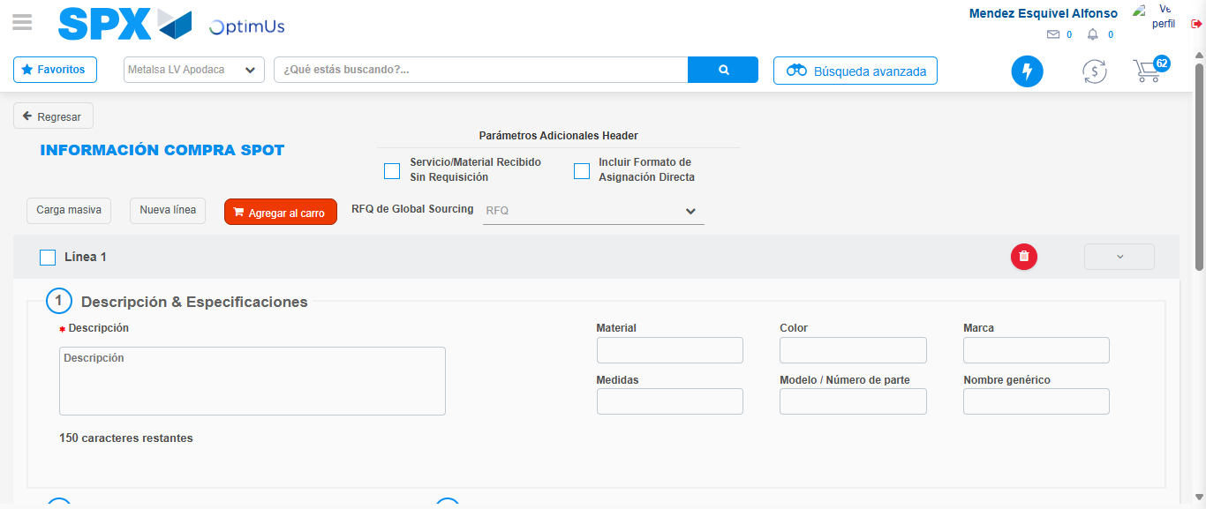Image file-name: QC_Testing-tc002_SPX_Dev5_Crear_Requisicion_Spot_Tipo_Cobro_Project-1784308388275

Step 7 - Return to Main Page SPX : Return to Main Page SPX
Image file-name: QC_Testing-tc002_SPX_Dev5_Crear_Requisicion_Spot_Tipo_Cobro_Project-1784308356957

Image file-name: QC_Testing-tc002_SPX_Dev5_Crear_Requisicion_Spot_Tipo_Cobro_Project-1784308359399

Image file-name: QC_Testing-tc002_SPX_Dev5_Crear_Requisicion_Spot_Tipo_Cobro_Project-1784308368462

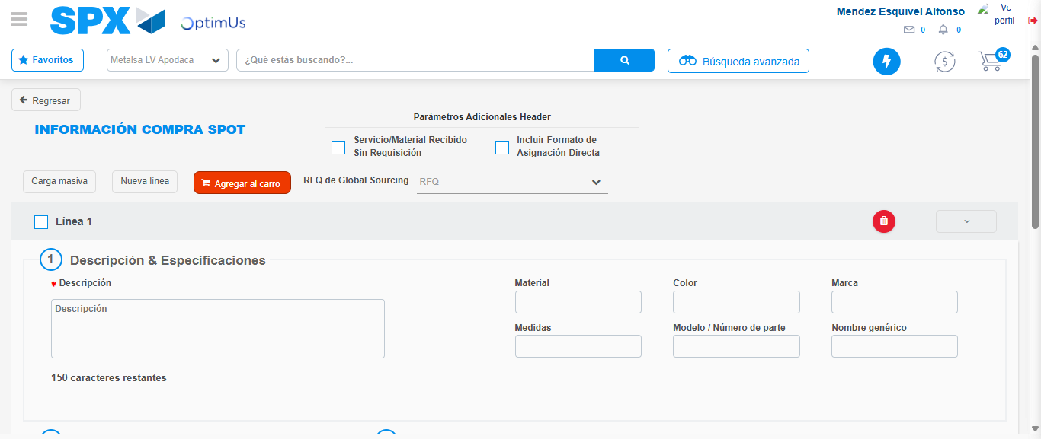Image file-name: QC_Testing-tc002_SPX_Dev5_Crear_Requisicion_Spot_Tipo_Cobro_Project-1784308390488

Image file-name: QC_Testing-tc002_SPX_Dev5_Crear_Requisicion_Spot_Tipo_Cobro_Project-1784308390688

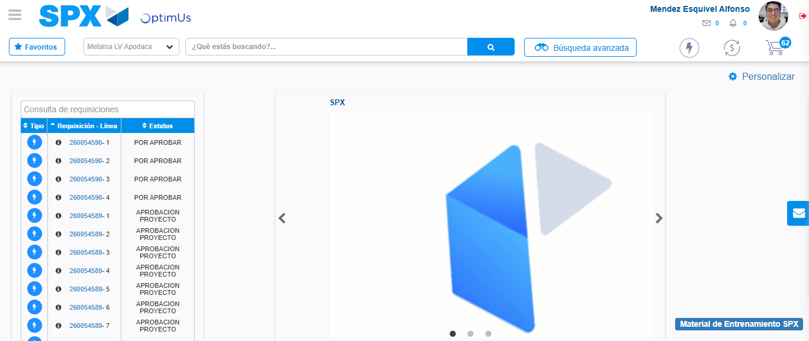Image file-name: QC_Testing-tc002_SPX_Dev5_Crear_Requisicion_Spot_Tipo_Cobro_Project-1784308411819

Step 8 - Log Out : Log Out SPX
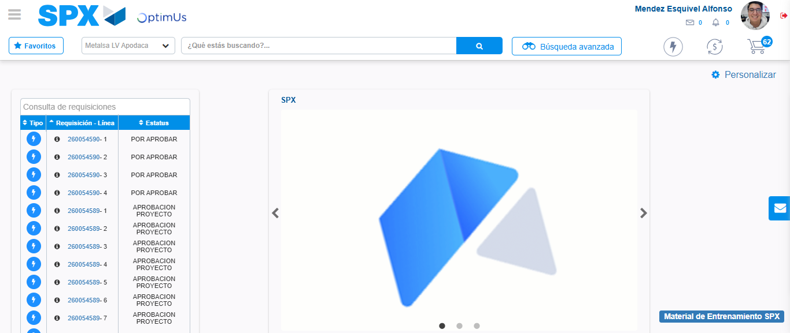Image file-name: QC_Testing-tc002_SPX_Dev5_Crear_Requisicion_Spot_Tipo_Cobro_Project-1784308412105

